Download the Application From play store and open it

When a new user is downloading this application from playstore, the user must log in to create a profile and password to complete the setup process.

Here’s how to LogIN for the first time:
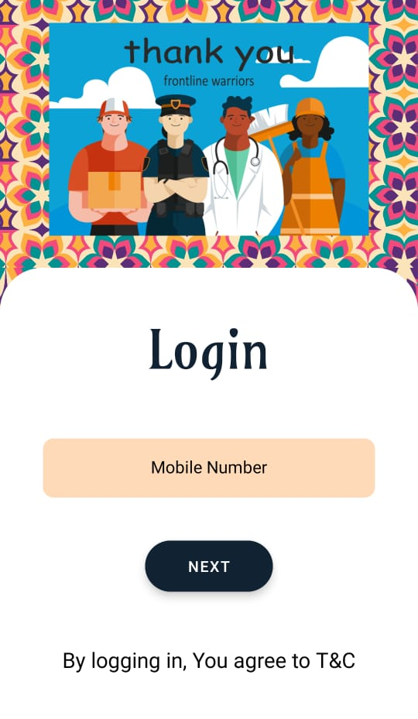
Figure 1

- Enter your valid phone number in given box.
(If the mobile number is new then
It will follow these processes.)
- Press next button to goto verification part

2
1

Enter your mobile number here

Then press next

- Check your inbox for the 'Number Verification' or ‘OTP – One Time Password’ in massage box.
This massage contains 6- digit code to complete the setup. Copy the code from the massage box and go to the application and paste in otp verification and press Submit.
Once you login to this application no need to verify your identity again and again.
It will automatically be logged in.

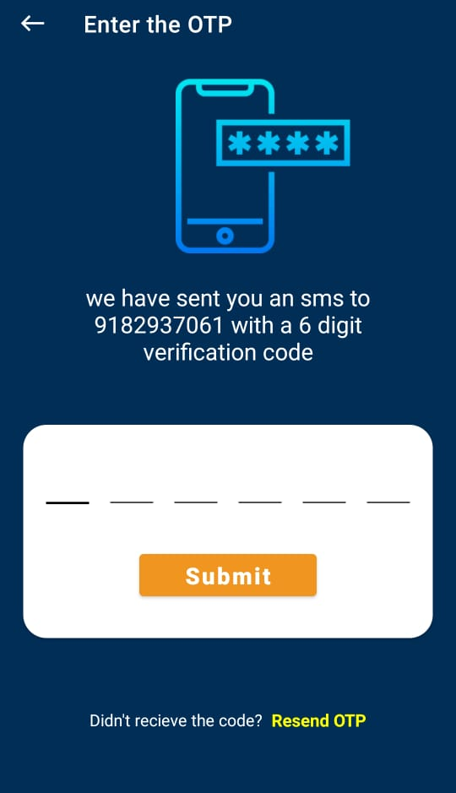
Figure 2

Your mobile number is showing here

Enter OTP Here

Press here to resend the OTP

- You Can resend the OTP with the help of Resend OTP option
Before we start adding user data in the database, we first need to create users which we will save the user data to in the database. This should be done after registering/signing in to the app and only if it is a new user.
If we are using Cloud Firestore, we can also use Firebase Authentication to register and sign in users. If we are implementing Firebase Authentication for the first time, I recommend using FirebaseUI, because it provides a pre-built UI and requires less work. We use FirebaseUI in the Sign in Fragment for Reply.

Among all of them, I am going to demonstrate about Firebase Authentication. Firebase authenticates the user by sending One Time Password (OTP) via SMS to their phones. The below image is useful to understand the process of Firebase Authentication.
How Firebase authentication works:-

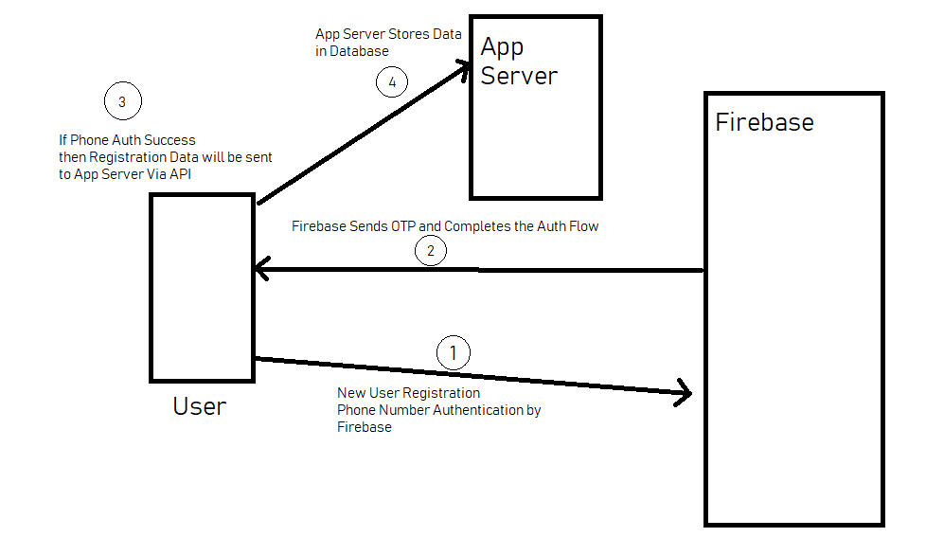
Steps to implement Firebase Authentication:-
- Add your project to Firebase. (See the previous blog)
- In your project level build.gradle file, add google’s maven repository in both buildscript and allproject section.
- In your app level build.gradle file, add Firebase authentication library.
implementation 'com.google.firebase:firebase-auth:19.2.0'
Now, in Firebase console enable “Phone sign-in method” from Authentication.
Designed our layout to get a user mobile number for Authentication.

Once the user enters the mobile number, you need to verify that number by sending an SMS to that phone number. Use verifyPhoneNumber() method of Firebase SDK along with the OnVerificationStateChangedCallbacks.
Figure 2

OnVerificationStateChangedCallbacks has 4 methods that need to be implemented in the code.
- onVerificationCompleted — This method can be called in 2 situations.
a. Instant verification — In some cases, no phone number can be verified without sending or entering the phone number.
b. Auto retrieval — Google play services automatically detect incoming messages and perform verification without user interaction.
- onVerificationFailed — This method invoked when the request is invalid. For ex: either mobile number or verification code is not correct.
- onCodeSent — This method invoked when OTP(Verification code) sent to the provided mobile number. Also, a verficationID will be provided for further uses.
- onCodeAutoRetrievalTimeOut — This method invoked when the time exceeds the specified timeout in verifyPhoneNumber method without completing the verification process. This method is optional.

After the user enters the verification code, create an object of PhoneAuthCredential and pass the OTP and verification ID-generated using onCodeSent() method as params.
PhoneAuthCredential credential = PhoneAuthProvider.getCredential(verificationId, otp);
Firebase enforces a limit on the number of SMS sent to a single mobile number within a limited period. And if you exceed the limit verification request might be restricted. If you find this problem during the development, whitelist the phone number from the Firebase console.
How to whitelist the phone numbers:-
- In the Firebase console, open the authentication section.
- In the sign-in method, the tab enables the phone provider.
- Provide the phone number you want to use during the development with the default verification code.
- Save the form.
Application Dashboard
OTP Verification
Login Page
